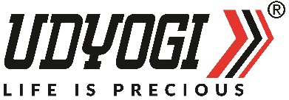

QUALITY POLICY

We, Udyogi Plastics Private Limited, shall aim to achieve and sustain excellence in our all activities by identifying the organizational issues, needs & expectations of the interested parties. We shall provide superior quality products and maintain credibility in the system for the quality of our products all the times.
The organization is committed to provide state-of-the-art product at Udyogi Plastics Private Limited with international standards.
We are further committed to develop a motivated workforce with a sense of pride in the organization which will lead us towards being the best in the industry and working in harmony with the environment.

This shall be achieved through: -

- Better management practices
- Modern & latest technologies in the manufacturing
- Continual improvement & effective measures
- Meet the statutory and regulatory requirement

We ensure for our customer: -
- The highest standards of manufacturing
- Safe environment
- Respect for right and privacy
- Access to a dedicated well-trained staff

Dated - 17/09/2025 For Udyogi Plastics Private Limited


NATWAR BAGRI

(Director)

